Identity Attack Detection Lab
Simulated identity attacks against Active Directory, detected with Splunk
Anele Nenngwekhulu — Home lab project · August 2026

1. Overview
This project simulates common identity-based attacks against an Active Directory domain controller and builds the detection side in Splunk. A Kali Linux attacker host was used to run password spraying, a targeted credential attack, account lockout, and Kerberoasting against the lab.local domain. Windows Security event logs from the domain controller (DC01) and a domain-joined Windows 10 client (WIN10) were forwarded into Splunk, where custom SPL searches were built to surface each technique from the raw event stream.
This document walks through the project from environment setup to attack execution to detection, with screenshots as evidence at each step. Credentials that were successfully discovered during the attack are redacted in the screenshots below.

2. Lab Environment
The lab runs entirely inside VirtualBox on an isolated internal network named AD-LAB.
Role | System | Details
Attacker | Kali Linux 2026.1 | NetExec (SMB), Impacket (GetUserSPNs)
Domain controller | DC01 | Windows Server 2022 (Build 20348), domain lab.local, 192.168.50.10, SMB signing on, SMBv1 off
Client | CLIENT01 / WIN10 | Windows 10 (64-bit), domain-joined, forwards Security logs
SIEM | Ubuntu 26.04 LTS | Splunk Enterprise 10.4.2, host 192.168.50.40, web UI on :8000
Hypervisor | Oracle VirtualBox | Internal network "AD-LAB", 192.168.50.0/24
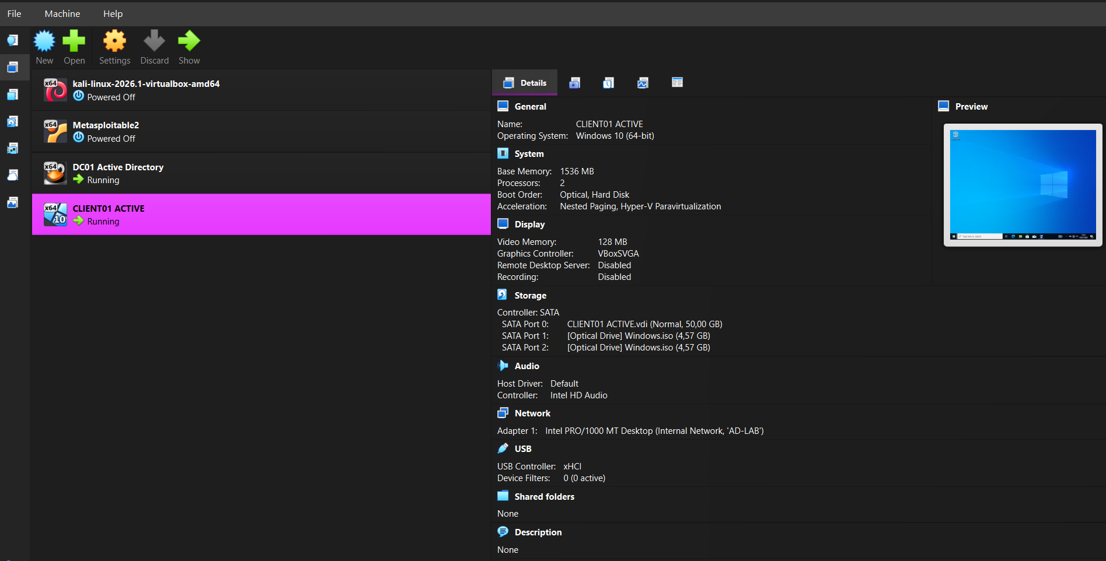
Figure 1: VirtualBox inventory — DC01 Active Directory and CLIENT01 running on the AD-LAB internal network.
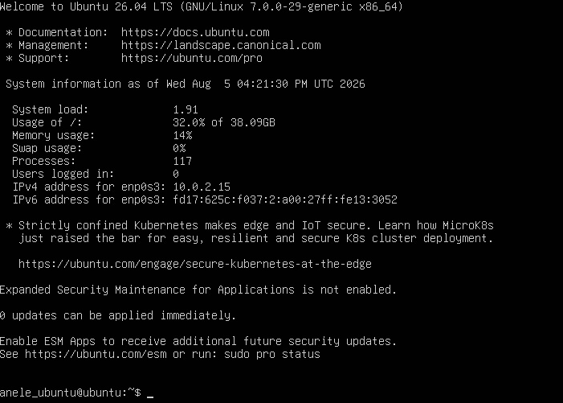
Figure 2: The Splunk collector host — Ubuntu 26.04 LTS, reachable on the lab network at 192.168.50.40.

3. Splunk Deployment
Splunk Enterprise was installed on the Ubuntu host and started as a service. A dedicated index named identity was created to hold the forwarded Windows Security event data from DC01 and WIN10, separate from Splunk's internal indexes.
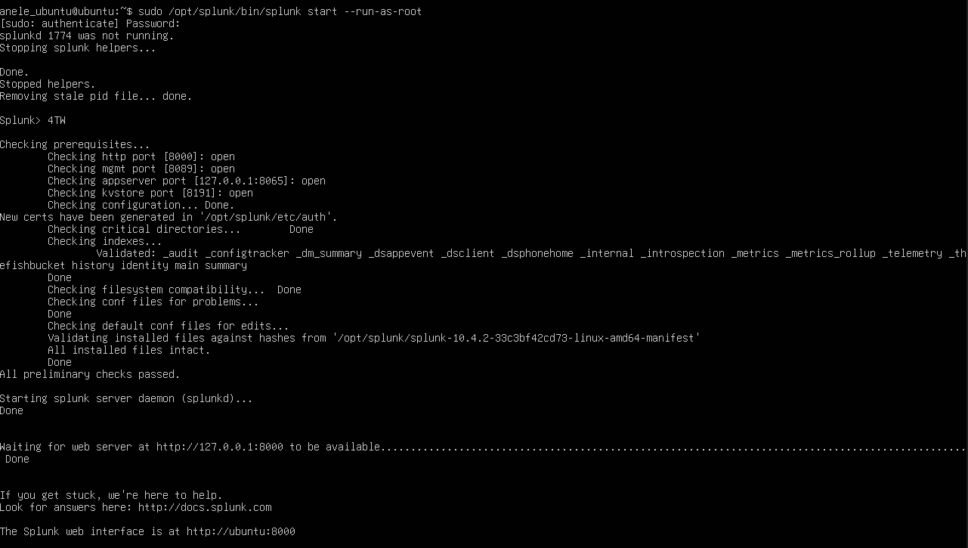
Figure 3: Starting splunkd — the identity index is validated alongside Splunk's internal indexes, and the web UI comes up on port 8000.
On the Ubuntu host, splunkd was confirmed running and listening, with the identity index receiving forwarded events:
sudo /opt/splunk/bin/splunk status
splunkd is running (PID: 90121).
splunk helpers are running (PIDs: 90122 90291 90295 90395 90407 94020 94021 96014).
sudo lsof -i :8000
splunkd 90121 root 96u IPv4 ... TCP *:8000 (LISTEN)
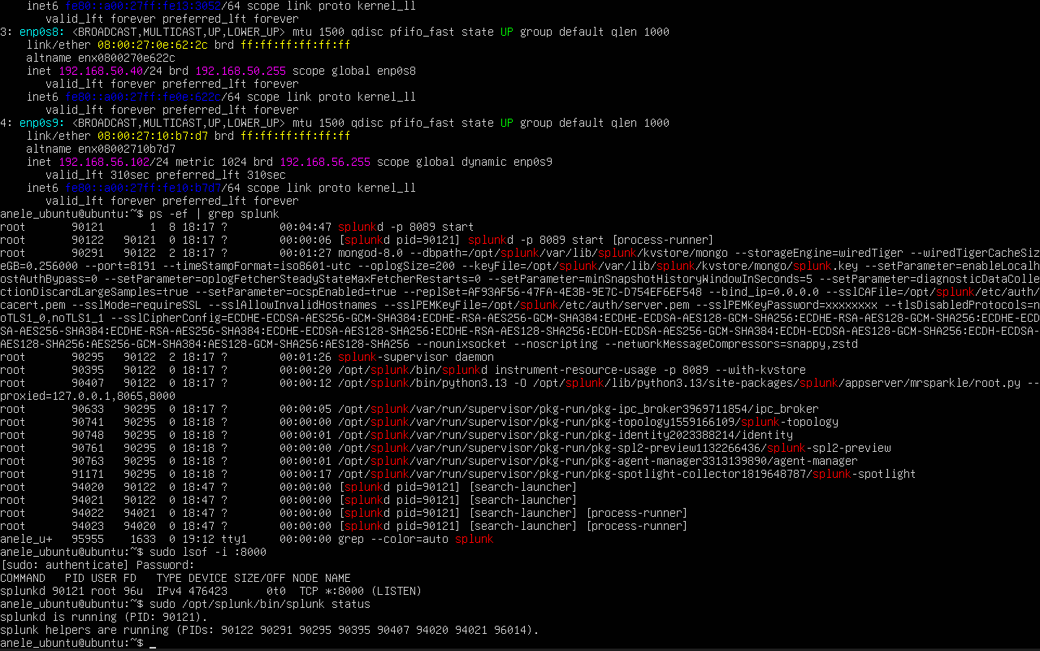
Figure 4: splunkd process tree and listener confirmed on the Ubuntu collector (network adapter enp0s8, 192.168.50.40/24 on AD-LAB).

4. Attack Chain
Four techniques were chained together against the domain: a low-and-slow password spray, a targeted dictionary attack that recovered a valid password, account lockout through repeated bad guesses, and Kerberoasting using the compromised account.

4.1 Password spraying
A single guessed password (Winter2026!) was tried against a list of five domain users in one pass — the classic spray pattern that avoids tripping a per-account lockout threshold.
netexec smb 192.168.50.10 -u users.txt -p "Winter2026!"
All five attempts (john.smith, jane.doe, michael.brown, sarah.wilson, david.miller) failed — the password did not match any account.
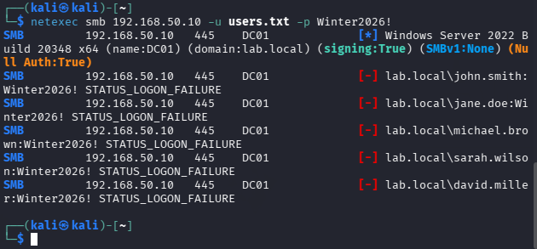
Figure 5: Password spray against five users with a single guessed password — all failures (STATUS_LOGON_FAILURE).

4.2 Targeted credential attack
With the spray unsuccessful, the attack shifted to a focused dictionary attack against one account, sarah.wilson, trying a short password list. The third attempt succeeded.
netexec smb 192.168.50.10 -u sarah.wilson -p passwords.txt
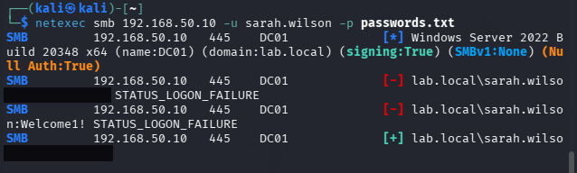
Figure 6: sarah.wilson's password recovered on the third guess ([+] = successful authentication). The discovered password is redacted.
This gave the attacker a valid, low-privilege domain credential to use for the rest of the chain.

4.3 Account lockout
The same dictionary approach was then run against jane.doe and john.smith. Both accounts had a lockout policy that tripped after five bad attempts, producing STATUS_ACCOUNT_LOCKED_OUT instead of further failures.
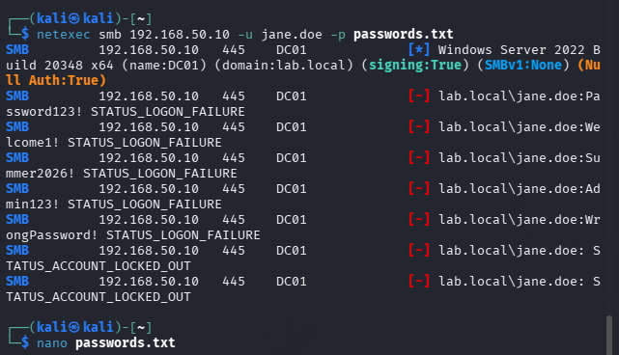
Figure 7: jane.doe locked out after five failed password guesses.
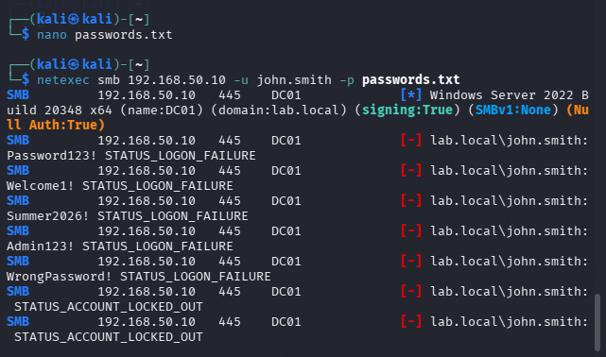
Figure 8: john.smith locked out the same way.
A second, more deliberate test repeated one wrong password against john.smith three times in a row to confirm the lockout threshold and observe the exact point of lockout:
netexec smb 192.168.50.10 -u john.smith -p WrongPassword123! (run 3×)
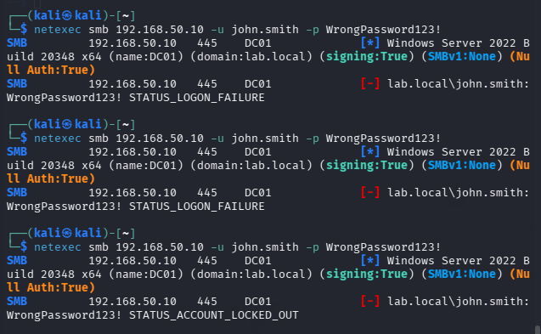
Figure 9: Two failures followed immediately by STATUS_ACCOUNT_LOCKED_OUT on the third attempt.
The lockout was confirmed directly on the domain with net user:
C:\Users\Administrator> net user john.smith /domain
Account active Locked
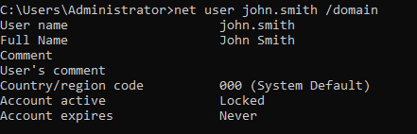
Figure 10: Domain-side confirmation — john.smith's account shows Locked.

4.4 Kerberoasting
Using the valid sarah.wilson credential recovered in 4.2, Impacket's GetUserSPNs was used to enumerate Kerberoastable service accounts and request a TGS ticket for one of them — svc_web, running HTTP/websvc01.lab.local. The ticket's encrypted portion was dumped as a crackable hash for offline attack.
impacket-GetUserSPNs lab.local/sarah.wilson:<redacted> -dc-ip 192.168.50.10 -request
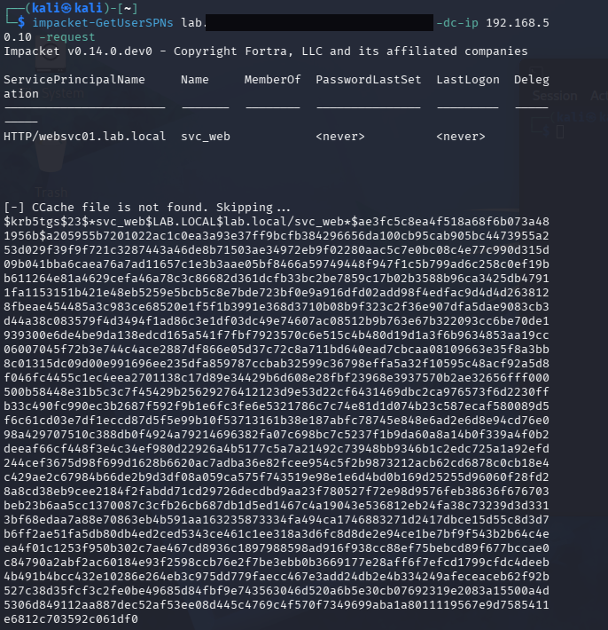
Figure 11: SPN enumeration finds svc_web (HTTP/websvc01.lab.local) and dumps its Kerberos TGS hash ($krb5tgs$23$...) for offline cracking. Credentials in the command are redacted.
This step shows the full privilege path a spray can open: a weak password on one ordinary user account led directly to a crackable credential for a service account, with no further exploitation needed on the wire.

5. Detection in Splunk
Each stage of the attack chain was detected from the identity index using SPL. The searches below group failed and successful logon events by account and source to surface spray, brute-force, and lockout patterns, and separately surface Kerberos ticket activity for Kerberoasting.

5.1 Failed logons — spray and brute-force (Event ID 4625)
index=identity EventCode=4625
| stats count values(Account_Name) as Users by Source_Network_Address
| where count >= 5
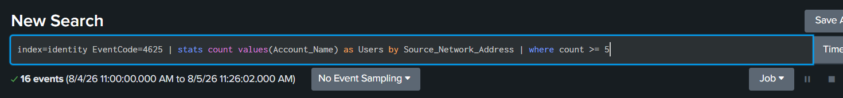
Figure 12: The spray-detection search — accounts failing to log on from the same source within the search window.
Narrowing the threshold to count >= 2 highlighted two sources generating repeated failures: the WIN10 client itself (127.0.0.1 and ::1), where john.smith and Administrator both failed more than once.
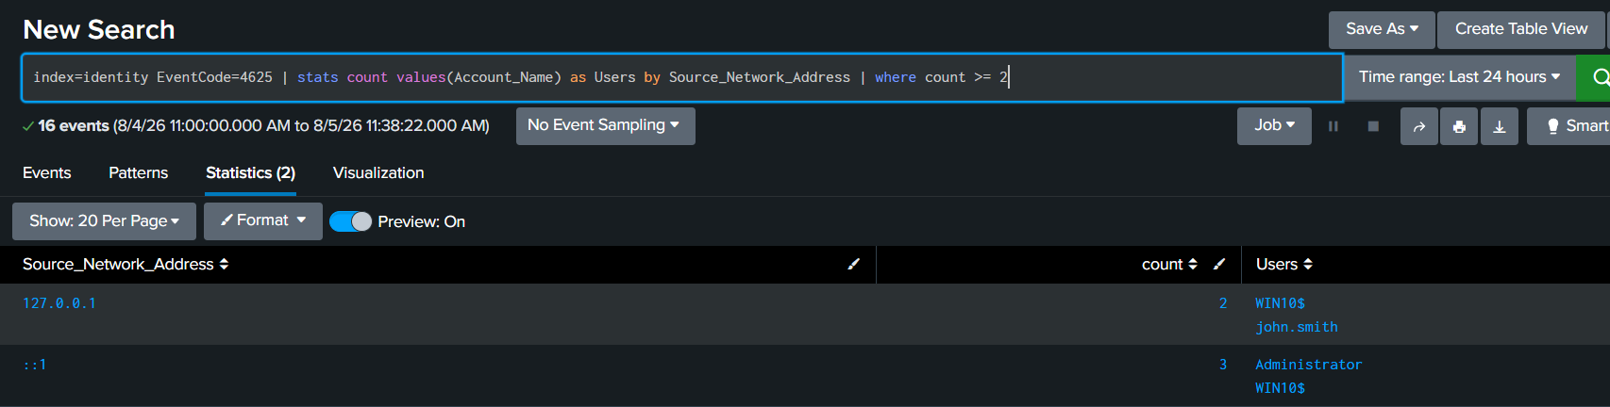
Figure 13: Lower-threshold view (count >= 2) — repeated failed logons grouped by source.
One limitation surfaced here: NetExec's remote SMB attempts did not populate Source_Network_Address in the forwarded Windows event, so the spray and the sarah.wilson/jane.doe/john.smith dictionary attempts land in the blank ("-") source bucket rather than a distinct attacker IP. Breaking the same data down by account instead of source isolates the affected users directly:
index=identity EventCode=4625
| stats count by Account_Name, Source_Network_Address
| where count >= 1
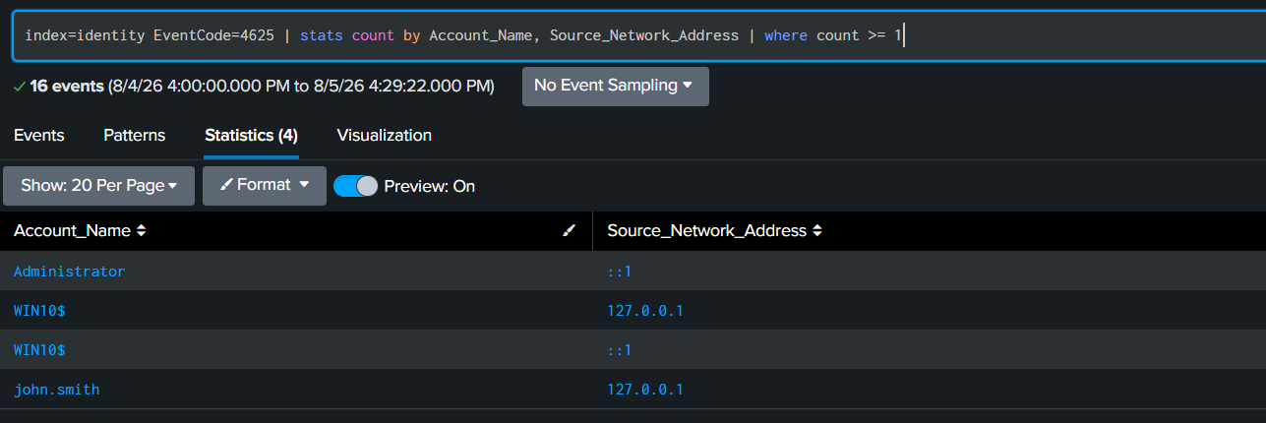
Figure 14: Failed logons broken down per account and source — isolates john.smith and Administrator's local (loopback) failures.
The raw event view confirms the detection is reading genuine Security-log 4625 events from the WIN10 host, alongside one Application-log noise event sharing the same event code:
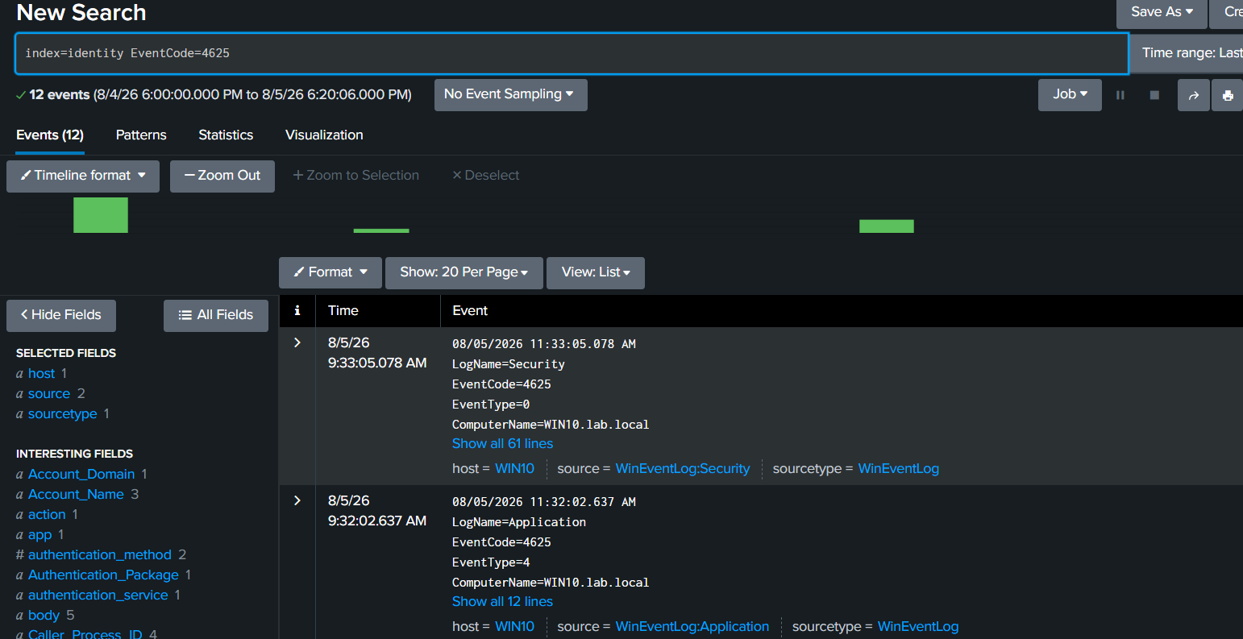
Figure 15: Raw 4625 events — mostly WinEventLog:Security from host WIN10, plus one Application-log entry worth excluding from the detection with a LogName filter.

5.2 Successful logons as a baseline (Event ID 4624)
Successful logons (4624) were pulled the same way to establish what normal authentication volume looks like on the domain, so spikes in 4625 can be judged against it rather than in isolation.
index=identity EventCode=4624
| stats count values(Account_Name) as Users by Source_Network_Address
| where count >= 5
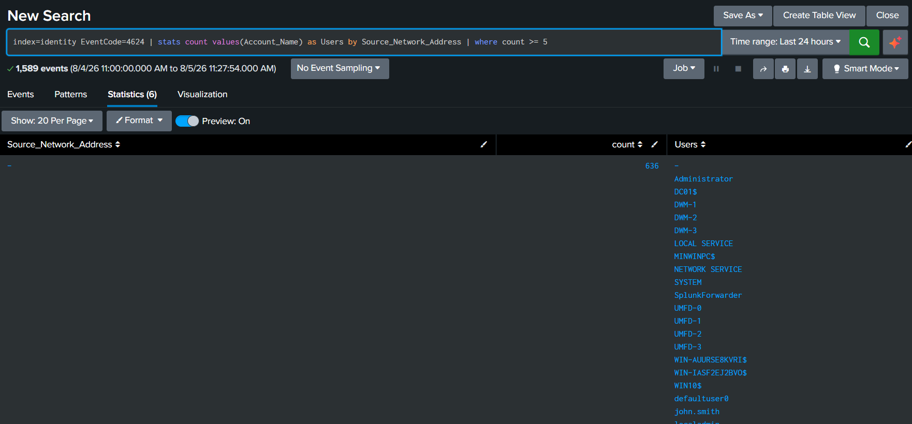
Figure 16: Baseline successful-logon volume — several hundred events from built-in and service accounts (Administrator, SYSTEM, DWM-*, UMFD-*), i.e. normal Windows background noise.
index=identity EventCode=4624
| stats count values(Account_Name) as Users by Source_Network_Address
| where count >= 2
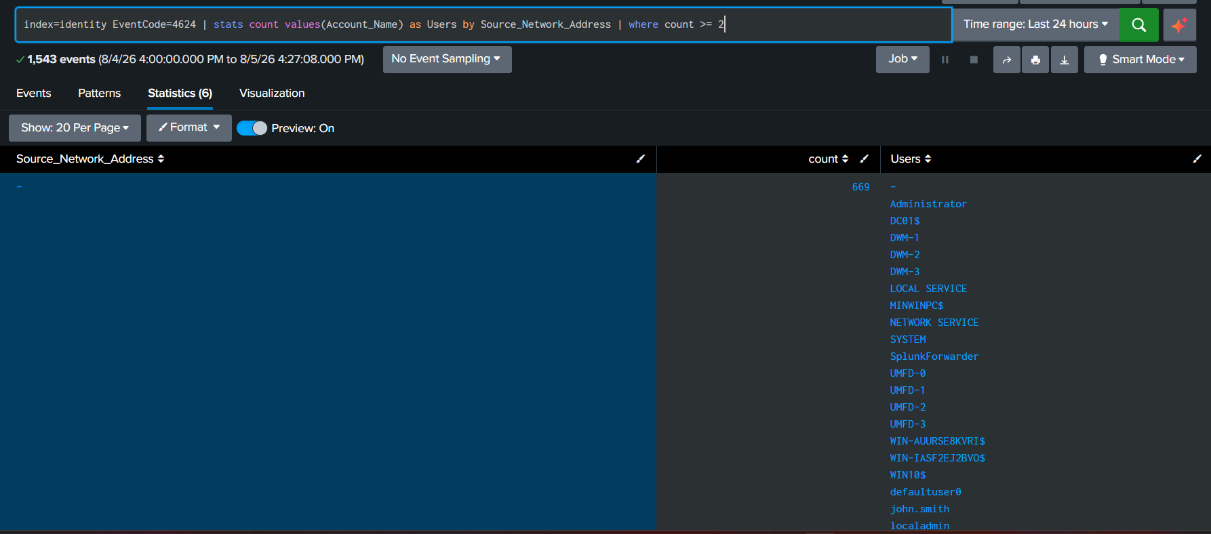
Figure 17: The same baseline at a lower threshold — confirms the volume is dominated by routine system accounts, not attacker activity.

5.3 Kerberos service ticket requests (Event ID 4769)
Kerberoasting shows up as TGS requests (4769) rather than logon events. Pulling all 4769 activity on DC01 over 24 hours returned 189 events across 8 pages — this is the surface a Kerberoasting detection rule would filter down, typically by flagging RC4 (etype 0x17) ticket requests for service accounts, which is unusual on a modern domain.
index=identity EventCode=4769
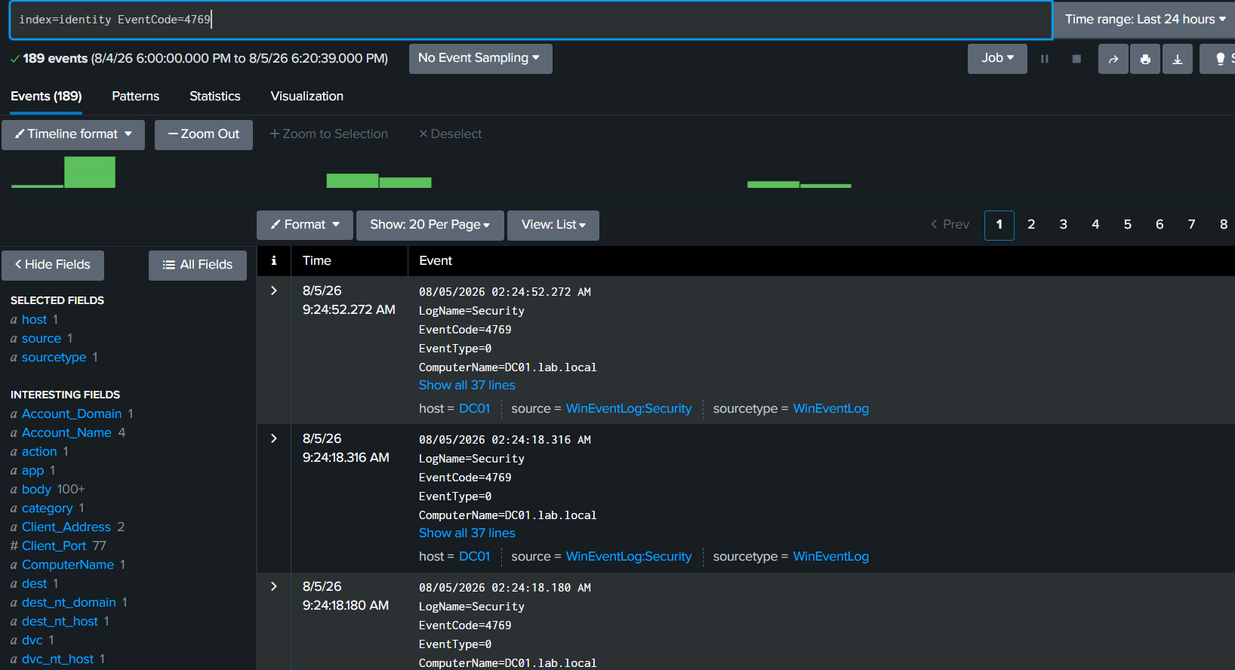
Figure 18: 189 Kerberos service-ticket-request events on DC01 in a 24-hour window — the pool a Kerberoasting rule narrows down.
A single 4769 event, expanded, shows the fields available for that detection rule — service name, account, client address, and ticket options:
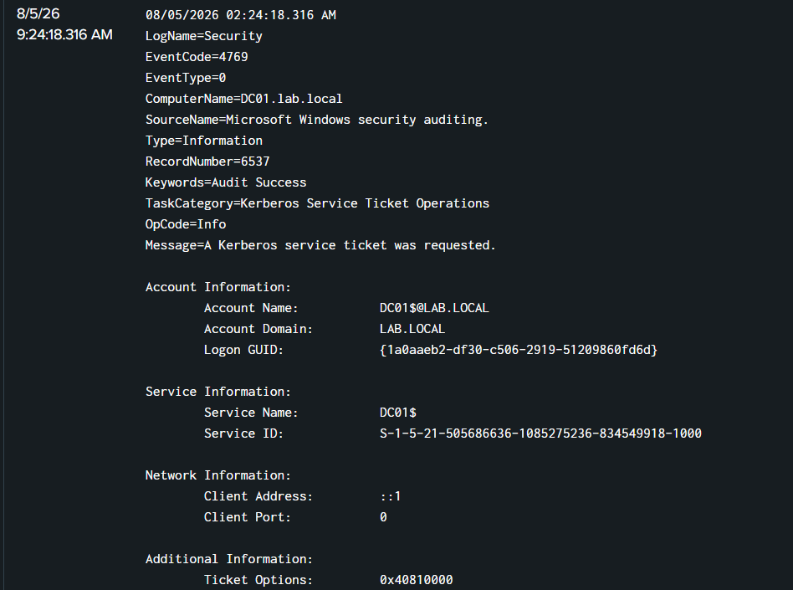
Figure 19: Event 4769 detail — a routine DC01$ service ticket request, shown here as an example of the event's field layout (Account Name, Service Name, Client Address, Ticket Options).
Note: this expanded example is a benign machine-account ticket request used to illustrate the event's fields, not the attacker's svc_web request from section 4.4 — isolating that specific request would need a filter on Service Name=svc_web or on the RC4 ticket-encryption type within the 189 events.

6. Detection logic summary
Technique | Source events | SPL pattern used
Password spray | 4625 | stats by Source_Network_Address, where count >= 5 — many accounts, one source, short window
Targeted / dictionary attack | 4625 then 4624 | Repeated 4625 for one account followed by a 4624 success from the same source
Account lockout | 4625 | A run of 4625 for one account ending without a matching 4624 (locked, not just failed)
Kerberoasting | 4769 | Volume of 4769 per account, filtered to RC4 (etype 0x17) tickets for service accounts

7. Findings and limitations
- NetExec's remote SMB failures did not carry a usable Source_Network_Address in the forwarded event — detections built only on that field would miss the spray entirely. Grouping by Account_Name as well closes that gap.
- Event ID 4625 is not unique to the Security log — one Application-log event shared the same code during this test. A production rule should filter on LogName=Security as well as EventCode.
- Lockout is best detected as the absence of a following success, not as a new event code: a locked account simply stops producing 4625/4624 pairs.
- The 4769 Kerberoasting search returned 189 events in 24 hours on a two-host lab domain; the attacker's one TGS request was not isolated from that volume in this pass and would need an etype or Service Name filter to surface it directly.
- sarah.wilson's recovered password was reused immediately for Kerberoasting — a single weak password led directly to a crackable service-account credential.

8. Next steps
- Add a saved search that filters Event ID 4769 to RC4 ticket-encryption type (etype 0x17) to isolate Kerberoasting requests from routine TGS traffic.
- Correlate 4625 bursts with the following 4624 or account-lockout state to auto-classify spray vs. successful compromise vs. lockout in one query.
- Forward Sysmon or PowerShell logging from WIN10 to catch the Impacket/NetExec tooling itself, not just its effect on the domain controller's Security log.
- Build out the identity index with benign baseline traffic over a longer window to tune the count thresholds used above.

9. MITRE ATT&CK mapping
Technique | ID
Brute Force: Password Spraying | T1110.003
Brute Force: Password Guessing | T1110.001
Account Discovery: Domain Account | T1087.002
Valid Accounts: Domain Accounts | T1078.002
Steal or Forge Kerberos Tickets: Kerberoasting | T1558.003

10. Skills demonstrated
- Active Directory attack simulation: password spraying, dictionary attacks, account lockout, Kerberoasting (NetExec, Impacket)
- Splunk deployment and index configuration for Windows Security log ingestion
- SPL detection engineering: stats, grouping, and thresholding across Event IDs 4624, 4625, and 4769
- Reading detection gaps from real data (missing source IPs, log-source noise) rather than assuming a query works
- MITRE ATT&CK mapping of an attack chain from initial access technique through credential theft

